Mini Project Data Analysis using Excel and Power BI
Name – Jomol Joseph

Dataset - Video Game Sales
Free Sample Dataset Download - Video Game Sales - Maven Analytics | Build Data Skills, Faster
Goal – This project’s goal is to analyse the total sales trends by genre like action, sports, puzzle, adventure, etc affect the game popularity. Also determining which genres are top performing.
Raw Dataset -
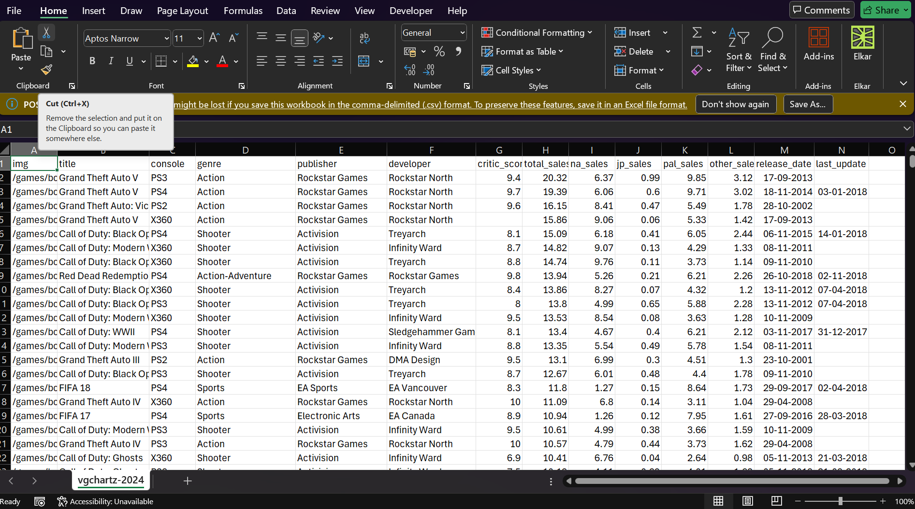
64107 rows and 12 columns, No duplicate values.
Data Cleaning -
- Removed the irrelevant columns such as ‘img’ & ‘last update’ by ‘CTRL + MINUS’.
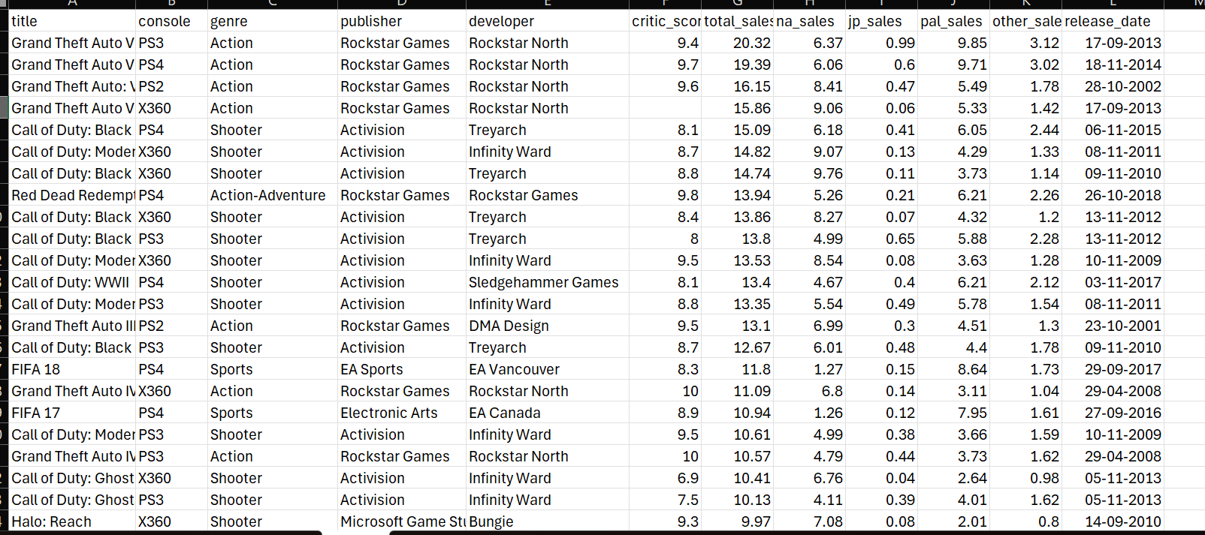
- Standardized the headers to proper case using the Proper function.
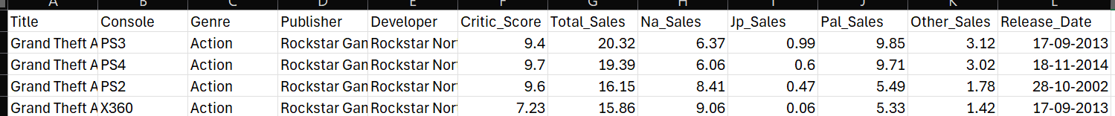
- Converted the entire dataset into a table.
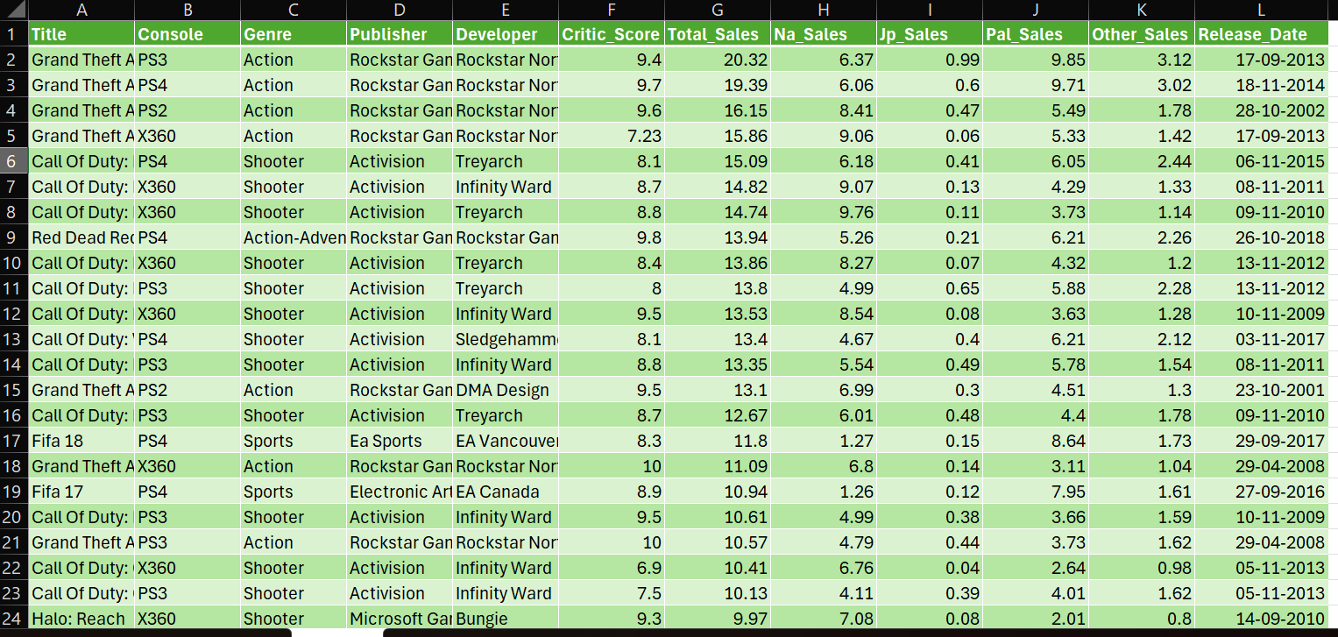

- Replaced the 17 missing values in ‘Developer’ column as ‘NA’ using the Find and Replace function.

- Formatted all the sales columns values into currency.
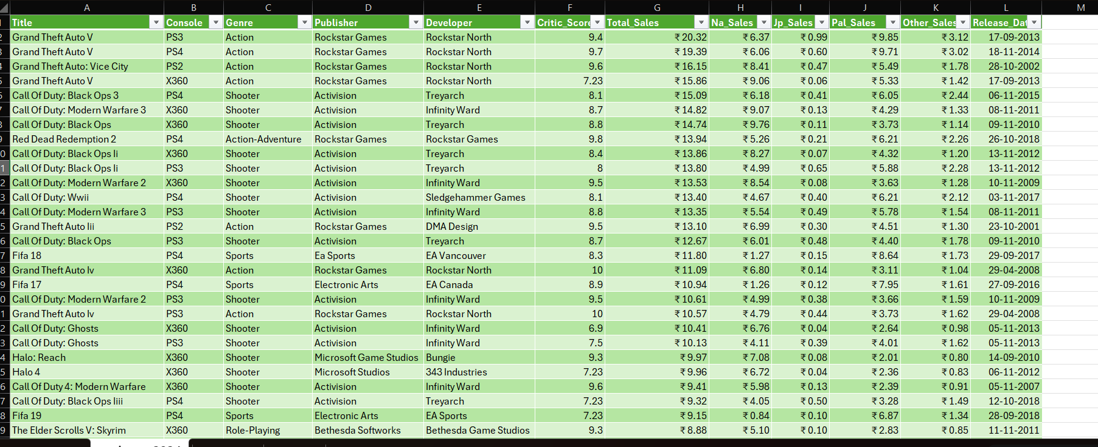
- Added a new column as Year.
- Filled the missing values in ‘Critic Score’ with the average of entire column with the ‘Go to Special’ blanks function.
=AVERAGE((Table3[[#All], [critic_score]])) = 7.23
- Total sales, Na Sales, Jp Sales, Pal Sales and Other Sales columns missing values are replaced with the average of those corresponding columns with the blanks function in Find and Replace.

- The missing values in the ‘Release Date’ column is filled with the values in the cell above using the formula: = IF (A2=" ", A1, A2)

- Sorted according to the Genres grouped together, with games inside each genre ranked by sales.

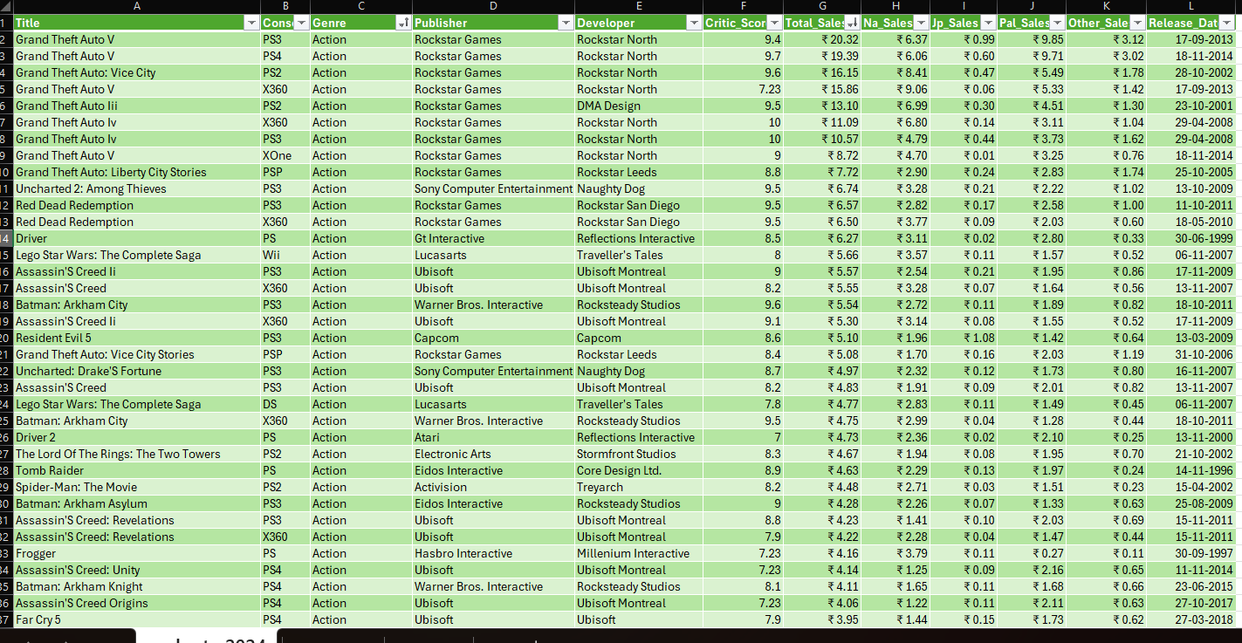

- Created a Pivot Table that shows the Total sales for each genre. Game popularity is measured using Total Global Sales.
(Units sold = higher popularity.)
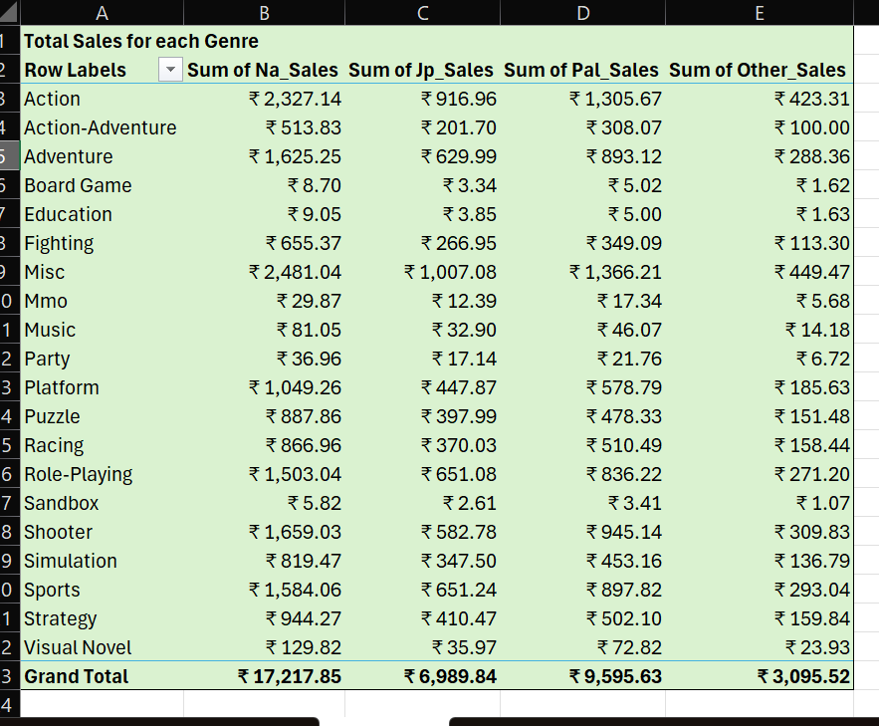
- The pivot table is sorted based on global sales and the genres that are most popular based on global sales are Misc, Action and Shooter.
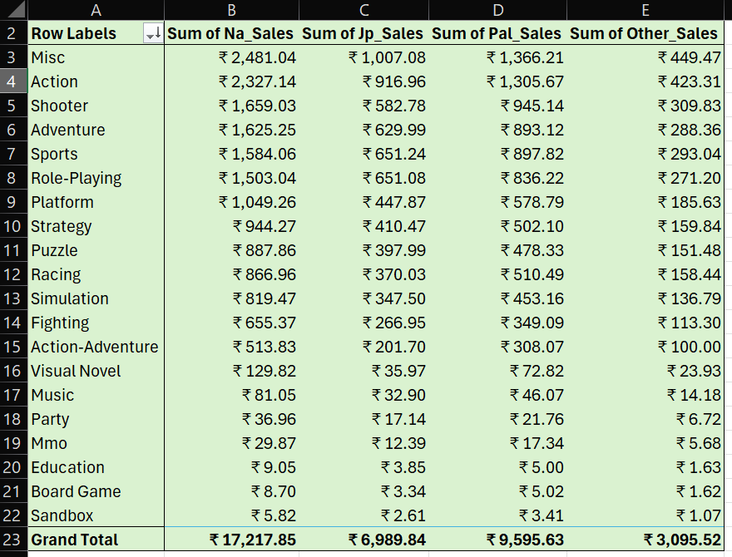
Therefore, genres like Misc, Action and Shooter shows higher popularity.
- Created another Pivot Table for determining which genres are top performing.

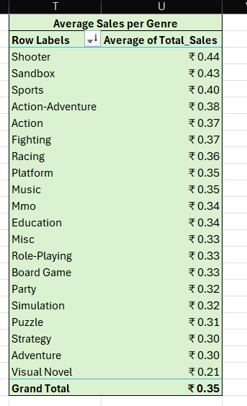
Therefore the top performing genres are Shooter, Sandbox and Sports.

